**PROJECT REPORT**

**ON**

**HOTEL BOOKINGS ANALYSIS**

**LANGUAGE USED : PYTHON**

**LIBRARIES USED : PANDA,NUMPY,MATPLOTLIB,SEABORN**

**MADE BY ROSHAK KUMAR**

**DATA ANALYSIS PROJECT STEPS**

Create a problem statement

Identify the data you want to analyse

Explore and clean the data

Analyse the data to get useful insights

Present the data in terms of reports

**RESEARCH QUESTIONS**

What are the variables that affect hotel reservations cancellations?

How can we make hotel reservations cancellations better?

How will hotels be assisted in making pricing and promotional decisions?

**HYPOTHESIS**

More cancellations occur when prices are higher

When there is a longer waiting list , customer tends to cancel more frequently

The majority of clients are coming from offline travel agents to make their reservations

**ANALYSIS AND FINDINGS**

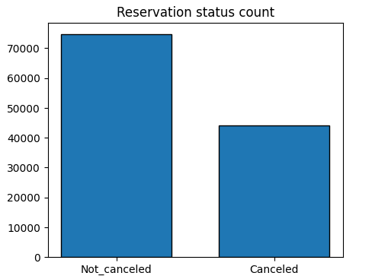

The bar graph shows the percentage of reservations that are cancelled and that those are not.It is obvious that there are still a significant number of reservations that have not been canceled.there are still 37% of clients who canceled their reservations,which has a significant effect on hotel earnings.

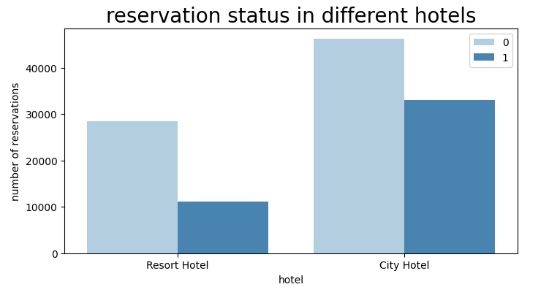

In comparison to resort hotel ,city hotels have more booking. its possible that resort hotels are more expensive than those in cities

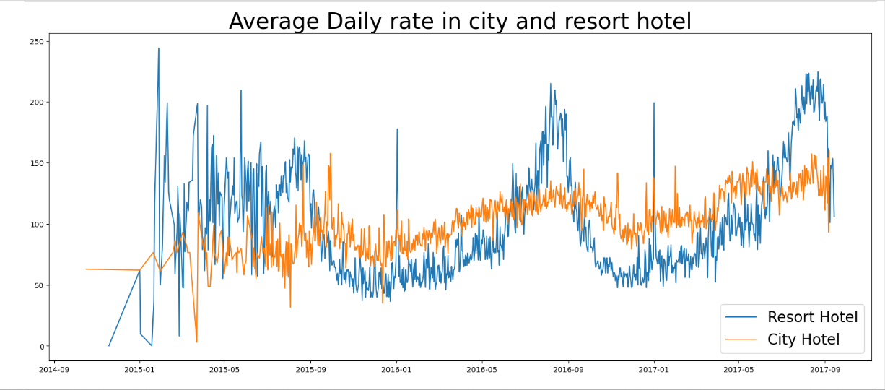

The line graph above shows that ,on certain days,the average daily rate for a city hotel is less than that of resort hotel and on other it is even less.it goes without saying that weekends and holidays may see a rise in resort hotel rates

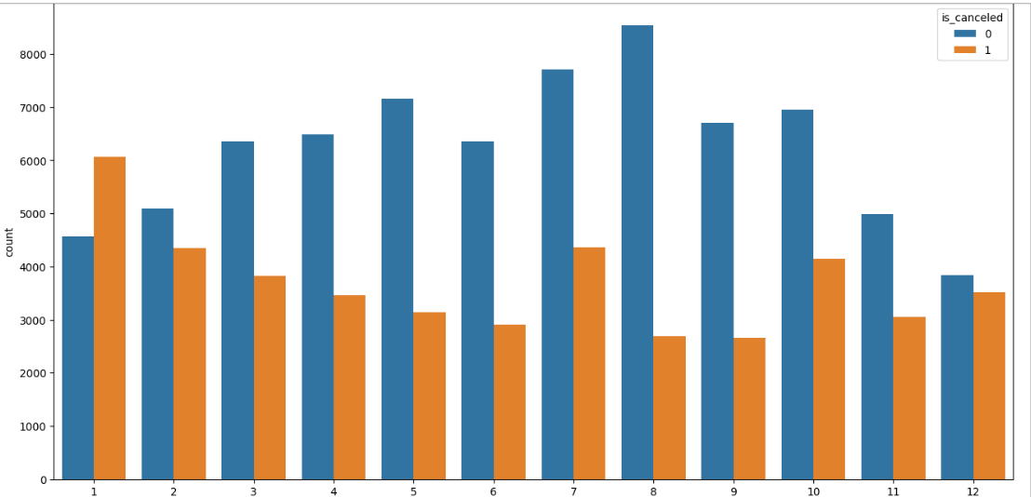

I have developed the grouped bar graph to anlyze the months with the highest and lowest reservations levels according to reservations status. As can be seen ,both the numbers of confirmed reservations and the number of cancelled reservations are largest in the month of august whereas January is the month with the most canceled reservations

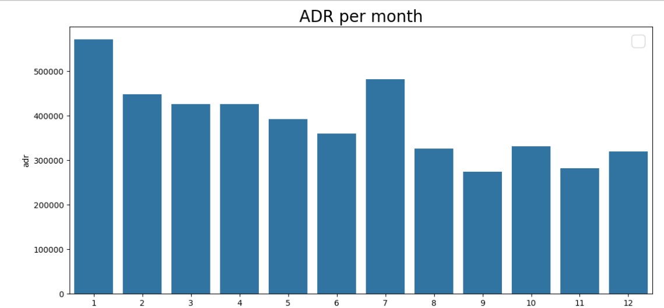

The bar graph demonstrates that cancellations are most common when prices are greatest and are leat common when thay are lowest.Therefore the cost of accommodation is solely responsible for the cancellations

Now lets see which country has the highest reservation canceled .the top country is Portugal with the highest number of cancellations

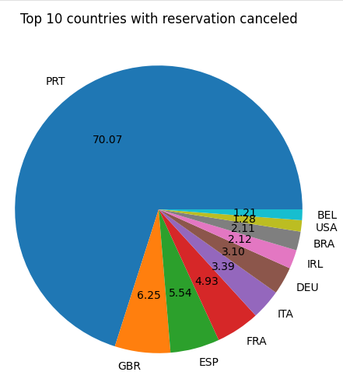

Lets check the area from where the guest are visiting the hotel and making reservations.is it coming from direct or groups,online or offline travel agents?Around 46% of the clients come from online travel agencies,whereas 27% come from groups .Only 4% of clients book hotels directly by visting them and making resrvations

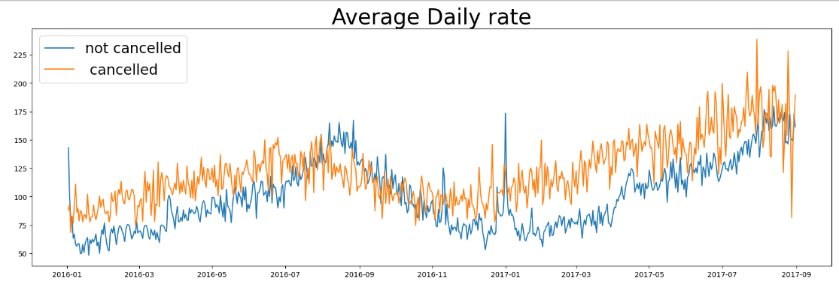

As seen in the graph ,reservations are canceled when the average daily rate is higher then when it sis not canceled .it clearly prove all the above analysis that the higher price leads to higher cancellations